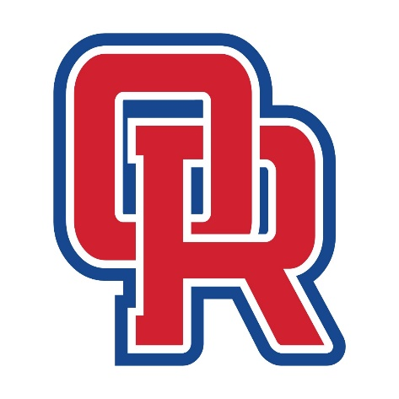
Spirit Day Dress Up Themes

9/25 Wrangle the Wildcats- western/ overalls

10/1- Lei out the Spartans- Hawaiian

10/8- Pink out the Wildcats

10/15-Blind the Bears- Neon

10/29- Tame the Tigers -Animal Print

11/6- Rock the Highlanders- Rock n Roll

11/13- HOCO

11/20- Crush the Cavs- Superhero

